ONLINE READING AND WRITING LABORATORY FOR CZECH, GERMAN, ITALIAN AND SLOVENIAN AS L2 PROJECT

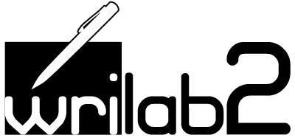

III INTERNATIONAL MEETING
9-10 March 2015

Venue: Venue: Soba rektorjev, Univerza v Ljubljani, Kongresni trg 12, 1000 Ljubljana

Monday 9 March 2015

10.30 -11.00 Anna Perissutti
Agenda outline, progress report, administrative and financial issues
11.00-11.30 Silvia del Longo:
Questionnaire's results
Coffee break
12.00-13.00 Gianluca Baldo
Presentation of one Wrilab2 Didactic Unit on Moodle
Lunch
14.00 -18.00 Valerie de Luca
Practical lab: adding interactive course material in Moodle

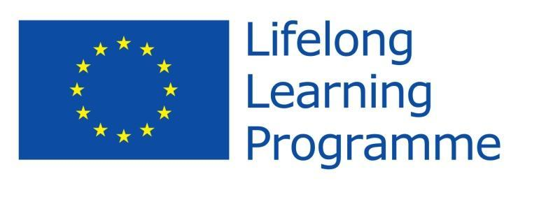
With the support of the LLP of the European Union

Tuesday 10 March 2015

8.30-9.30 Silvia del Longo, Anna Perissutti:
How to analyse and evaluate L2 argumentative compositions: a possible model
Coffee break
10.00-14.00
Practical Lab: Analysing L2 compositions - every language section will try to use the criteria presented to analyse one composition written in the respective L2.

With the support of the LLP of the European Union

