ONLINE READING AND WRITING LABORATORY FOR CZECH, GERMAN, ITALIAN AND SLOVENIAN AS L2 PROJECT

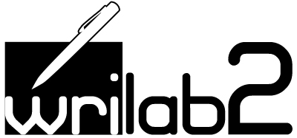

II INTERNATIONAL MEETING
11-12 September 2014

Venue: Sala Atti, Palazzo Antonini, via Petracco, 8 - 33100 Udine

Thursday 11 September 2014

13.30 – 14.00 Registration

14.00 – 14.30 Welcome - Agenda Outline, Progress report
Anna Perissutti

14.30-15.00 Technological Tour of Wrilab2
Valerie De Luca

15.00 – 15.30 Discussion

15.30 – 16.00 Coffee break

16-00 – 17.00 Methodoligical guidelines

Gerd Bräuer

17.00 – 18.00 Discussion on the methodological guidelines

20.00 Dinner at the Restaurant “Il Giardinetto”, Via Paolo Sarpi 8 , Udine

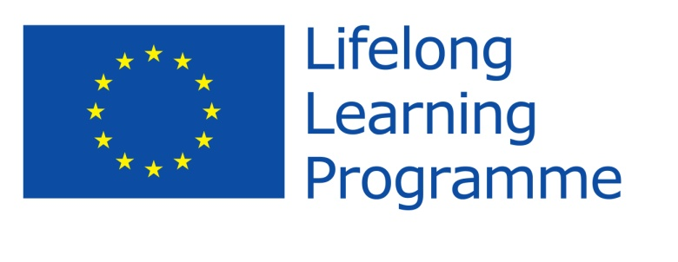
With the support of the LLP of the European Union

Friday 12 September 2014

9.00 – 13.00 Discussion on the methodological guidelines

The discussion should lead to the definition of a worksheet with the common criteria to be checked by each language group.

10.30 – 11.00 Coffee Break

11.00 – 13.00 Discussion on the methodological guidelines

13.00 – 14.00 Lunch at the Restaurant “Ai Frati”, Piazzetta Antonini, 5, Udine

14.00 14.20 Rationale behind the questionnaire
Silvia del Longo

14.20 – 14.30 Discussion

14.30-14.50 First results of the questionnaires: preliminary analysis
Gianluca Baldo

14.50 – 15.00 Discussion

15.00-15.20 Analysis results of the compositions written in L2 Czech
(based on the Czech Learner Corpus)
Anna Perissutti

15.20- 15.30 Discussion

15.30 – 16.00 Coffee break

16.00-16.30 Discussion on the dissemination strategy

16.30 – 17.00 Assignments of tasks and Meeting Closure

With the support of the LLP of the European Union

